 An Ecumenical

**Christmas Carol**

**Celebration Service**

You are cordially invited to join us for a joyous Ecumenical Christmas Carolling get-together

**Date: Friday, 6th December 2024, 6pm**

**Venue: St Mary’s Catholic Church** **Nihil St Street, Alexandra**

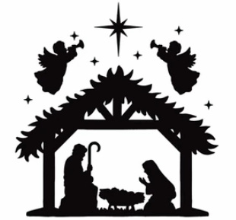



Refreshments will be served after the service.

For further information contact: Fr. Mario Hendricks

Mobile 0435 953 777 or email: mdphen@yahoo.com